

**Cloud Deployment Models**

**Name:** Pratham Kandari

**Sap Id:** 500097663

**Batch:** 7

**LAB- 4**

**Deploy a Linux VM from an ISO image**

Step 1) Login to your Openstack Dashboard.

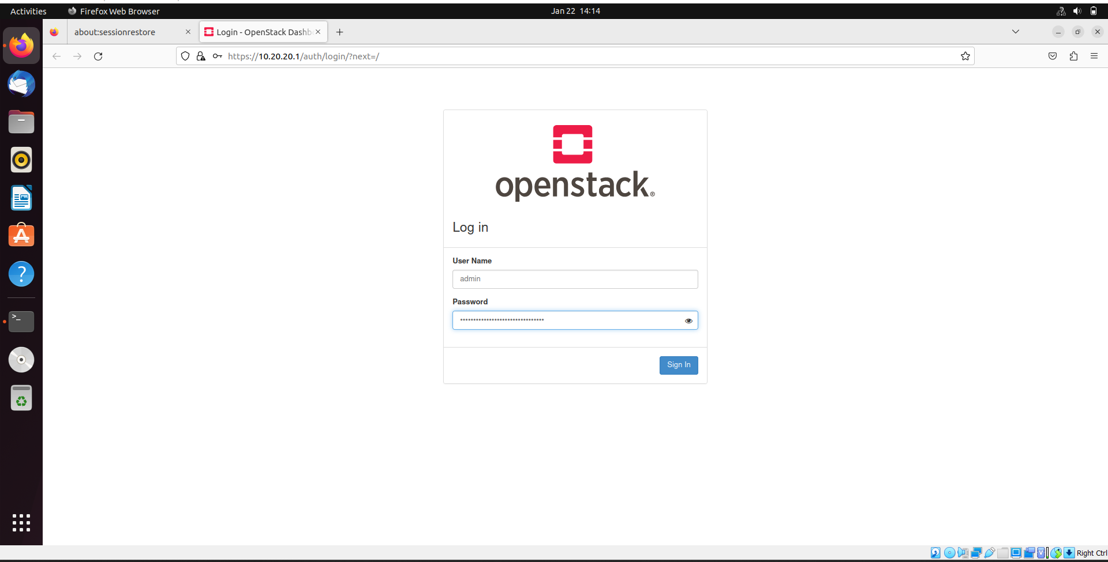

Step 2) Go to Compute -> Key pairs.

And create a Key pair, Give it a name and select Type -> SSH.

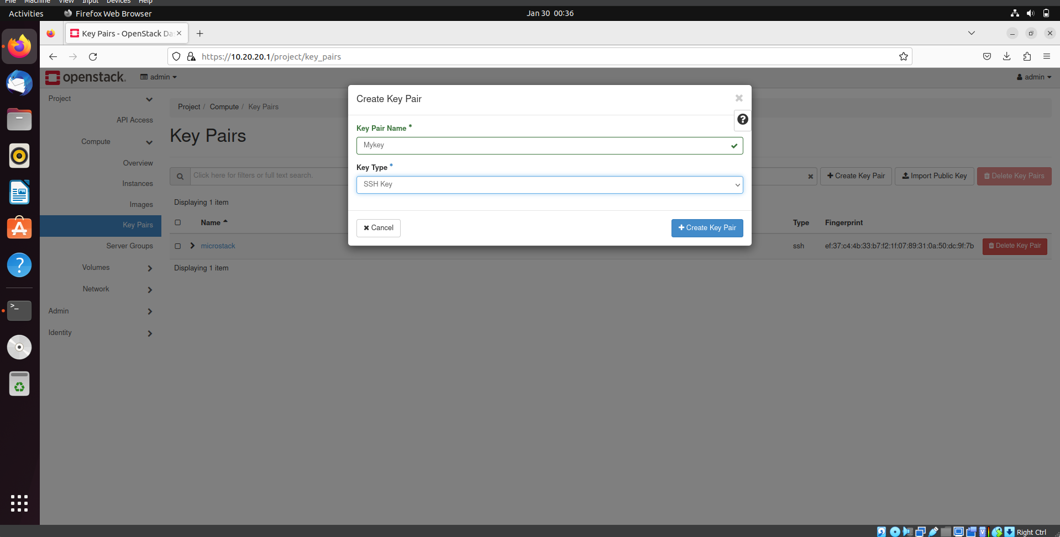

Step 3) A key pair will be created.

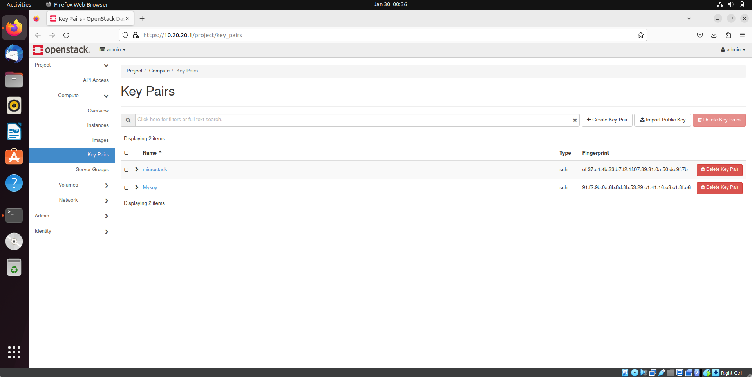

Step 4) Now go to Compute -> Images.

And click on Create Image.

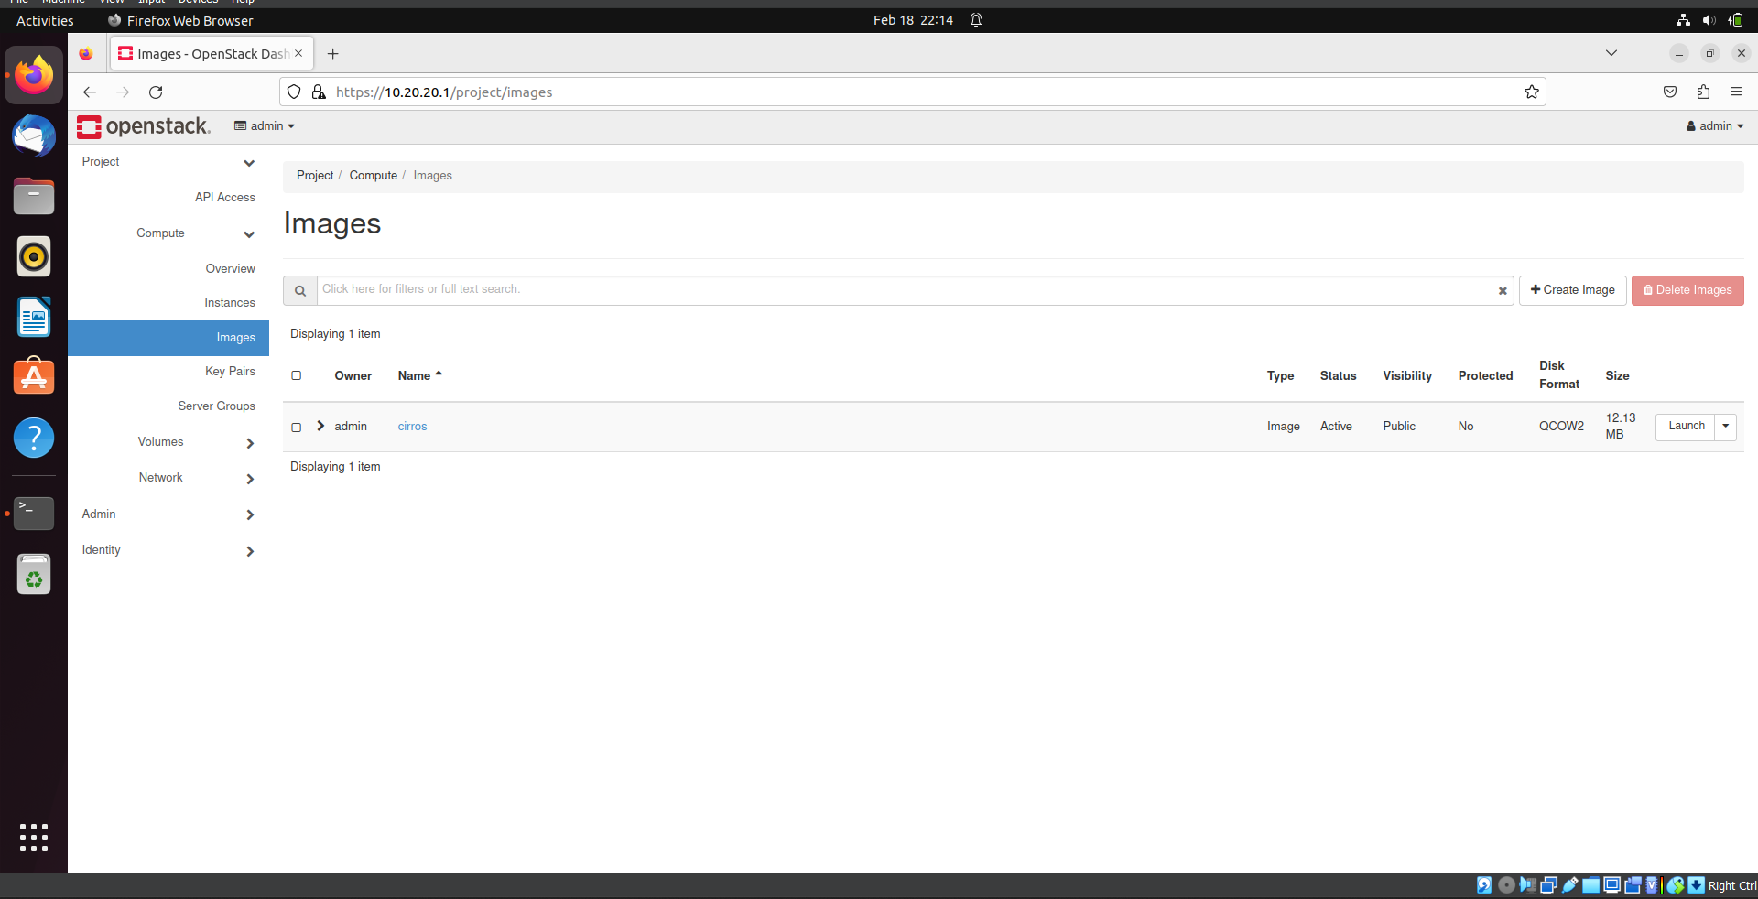

Step 5) Give it a name.

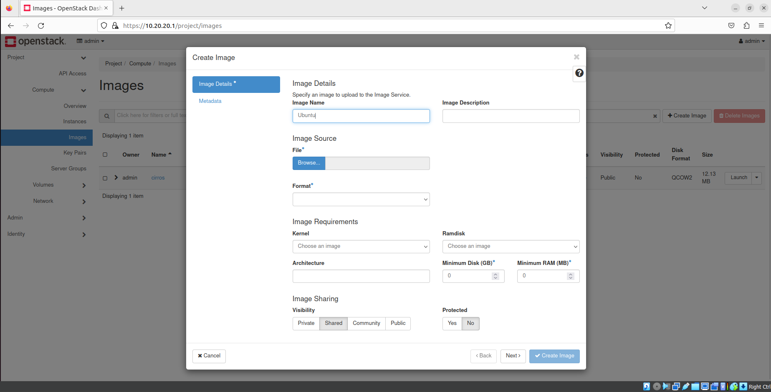

Step 6) Upload the iso file(here we used ubuntu), select the format and Create the Image.

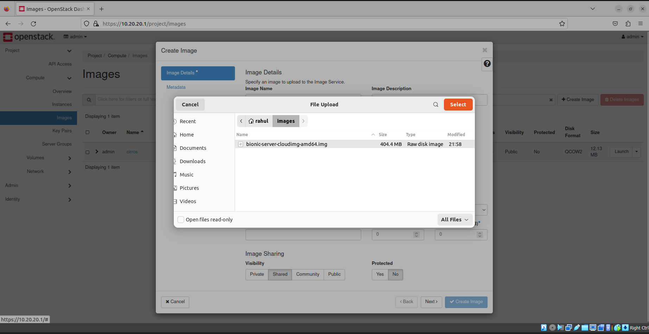

Step 7) Your Image file is created.

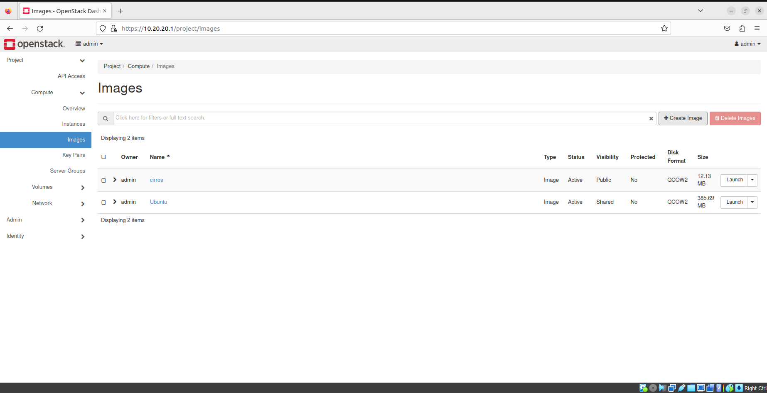

Step 8) Now go to Compute -> Instance and click on create Instance.

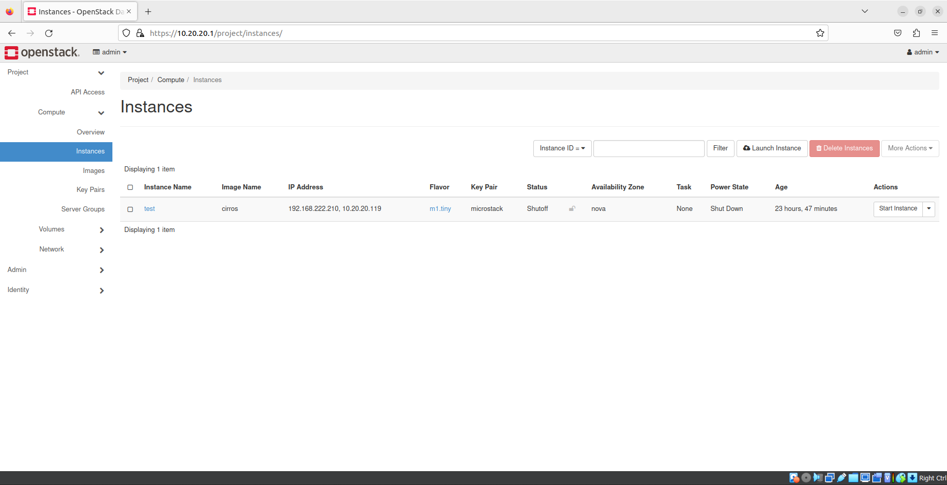

Step 9) Give it a name, select Availability Zone -> Nova and click on next.

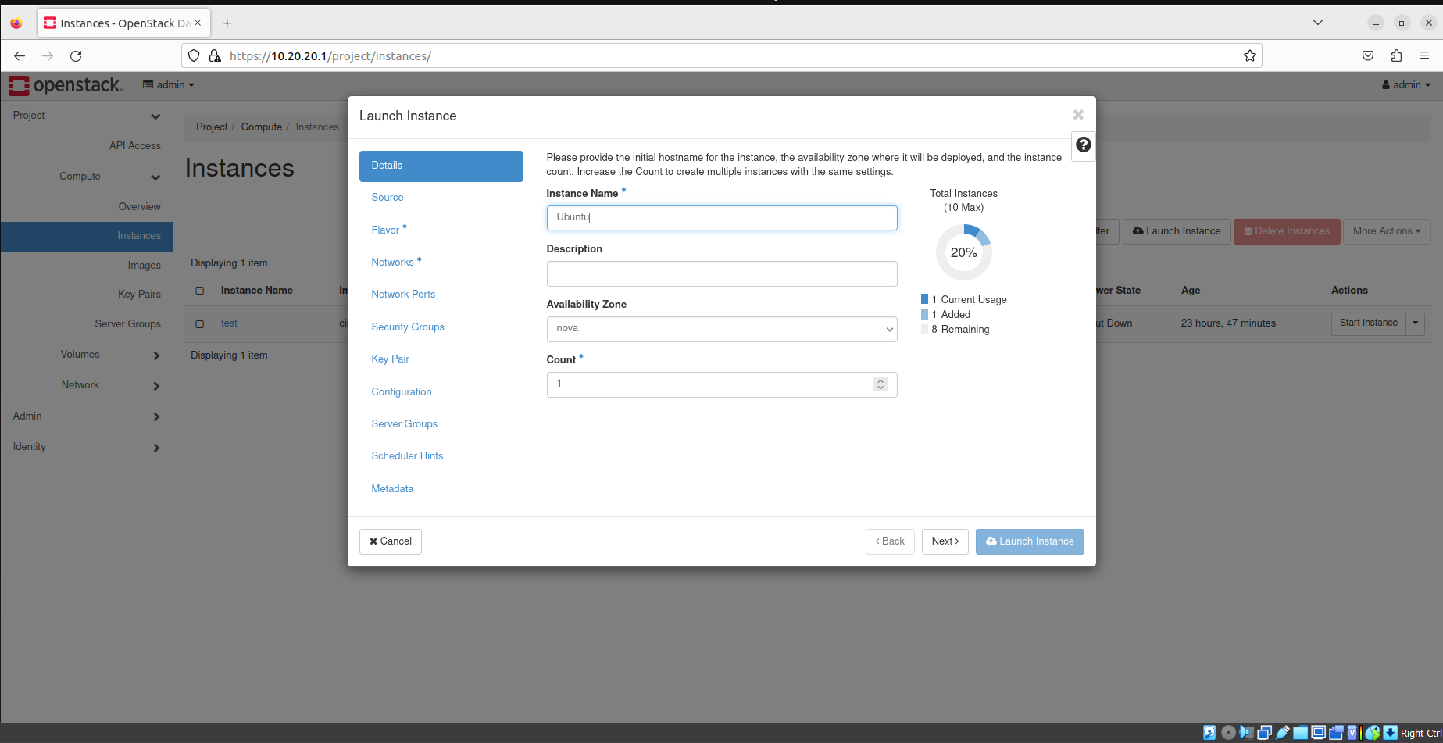

Step 10) Select your Image file and click on next.

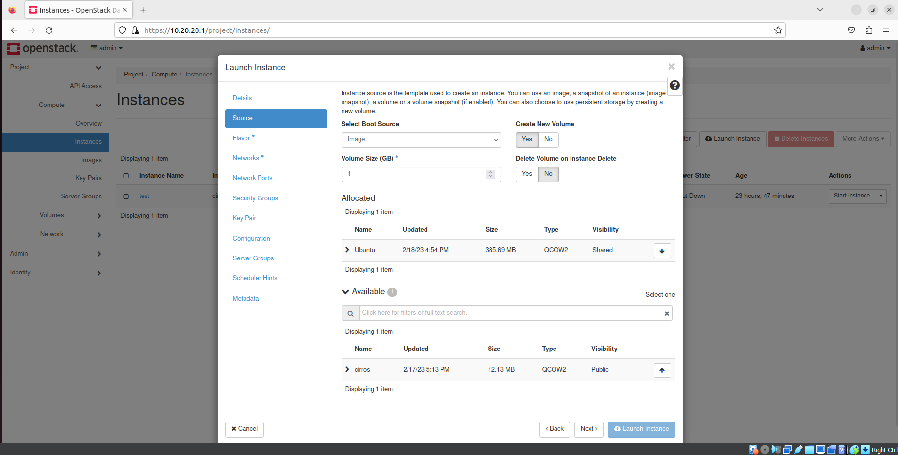

Step 11) Now select a flavour according to need, here we selected m1.small and click on next.

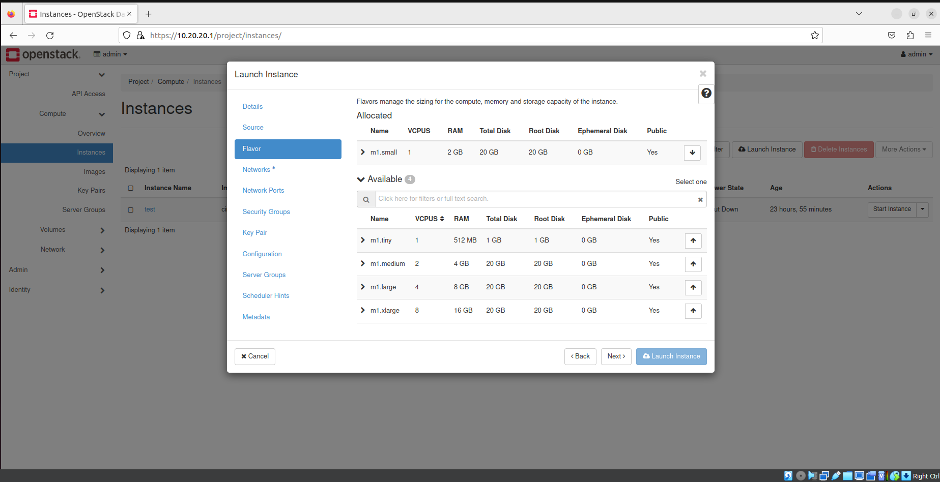

Step 12) Under Networks select both networks.

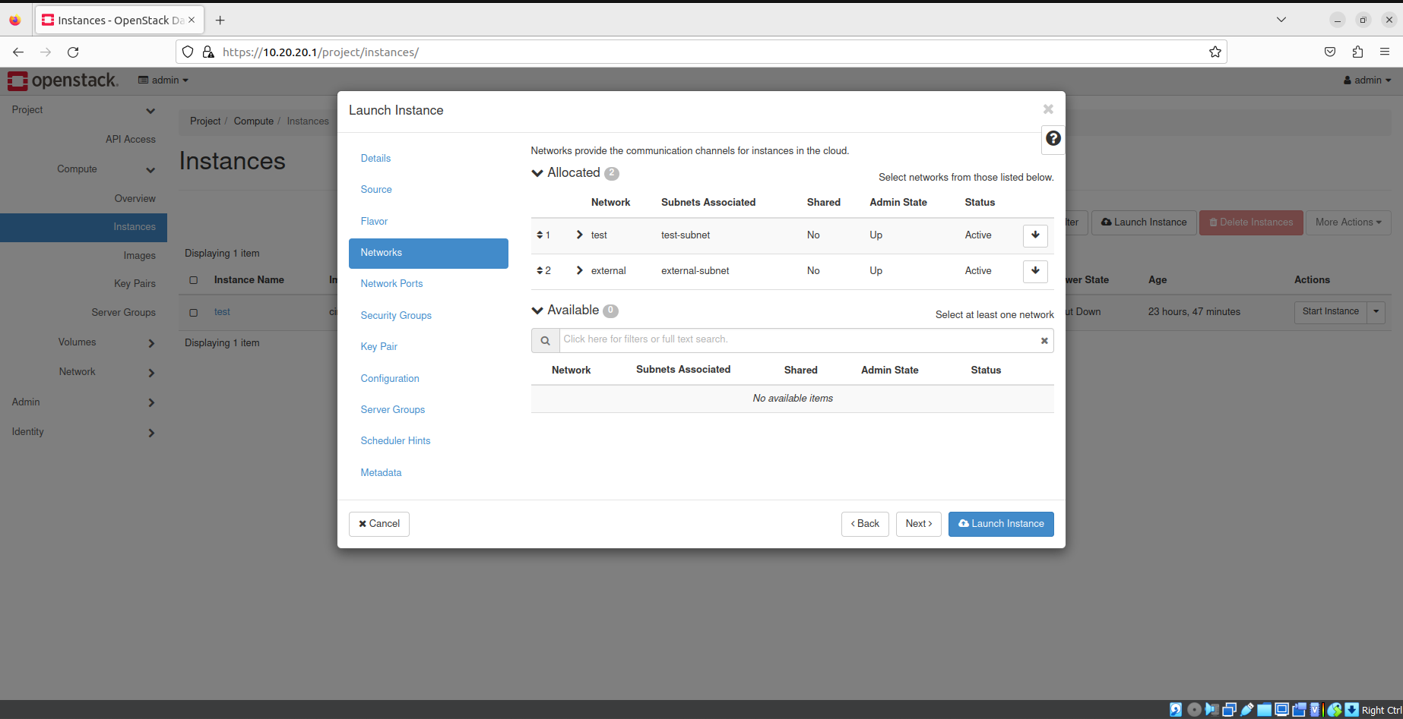

Step 13) Let network ports be default.

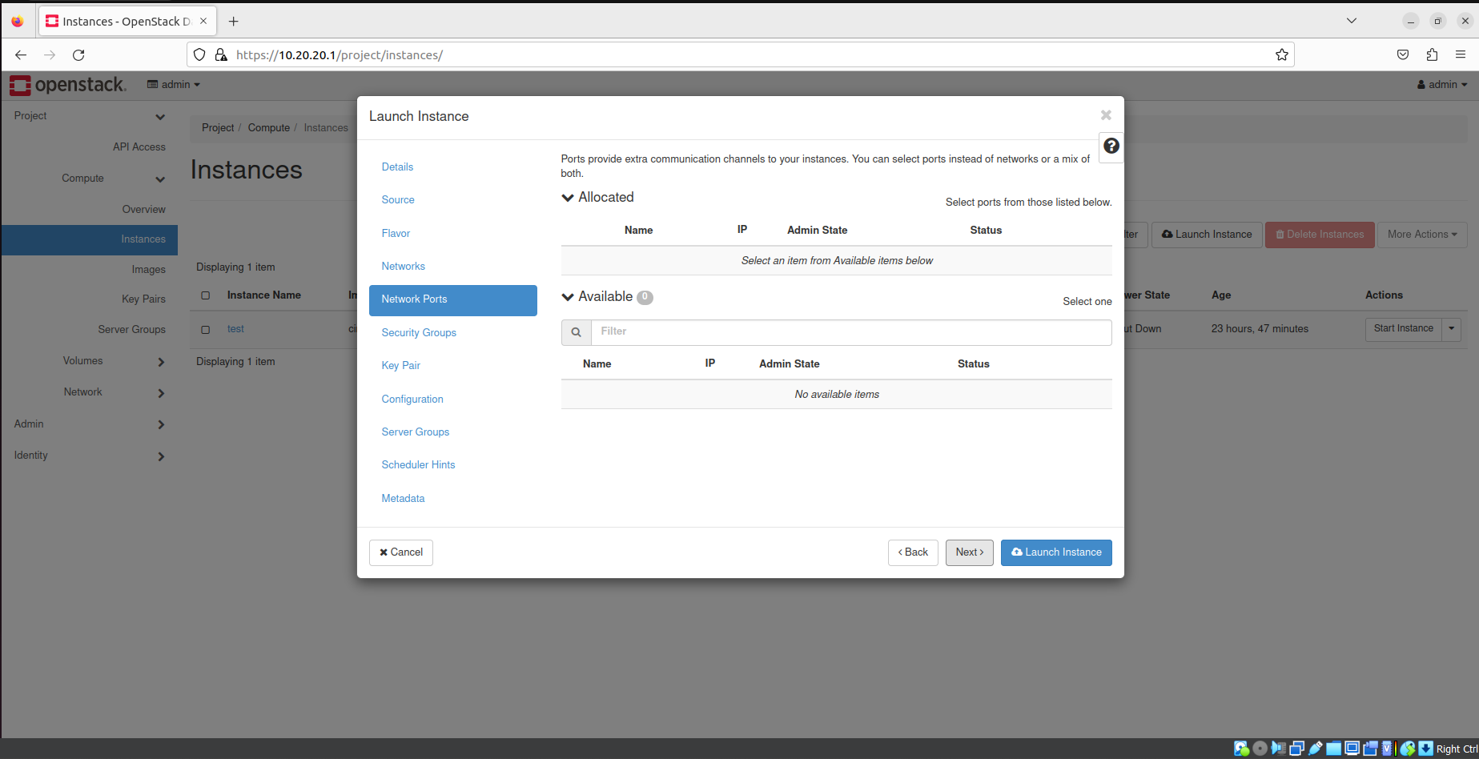

Step 14) Under Security Groups select the default group or you can create, and click on next.

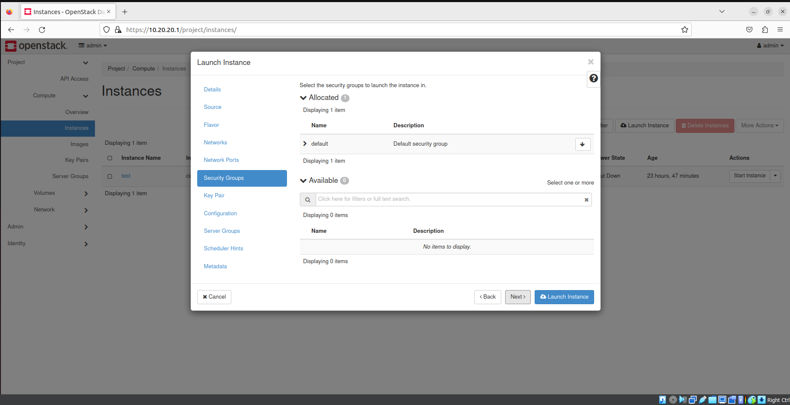

Step 15) Under key pair we will use the key pair created before, and launch the instance.

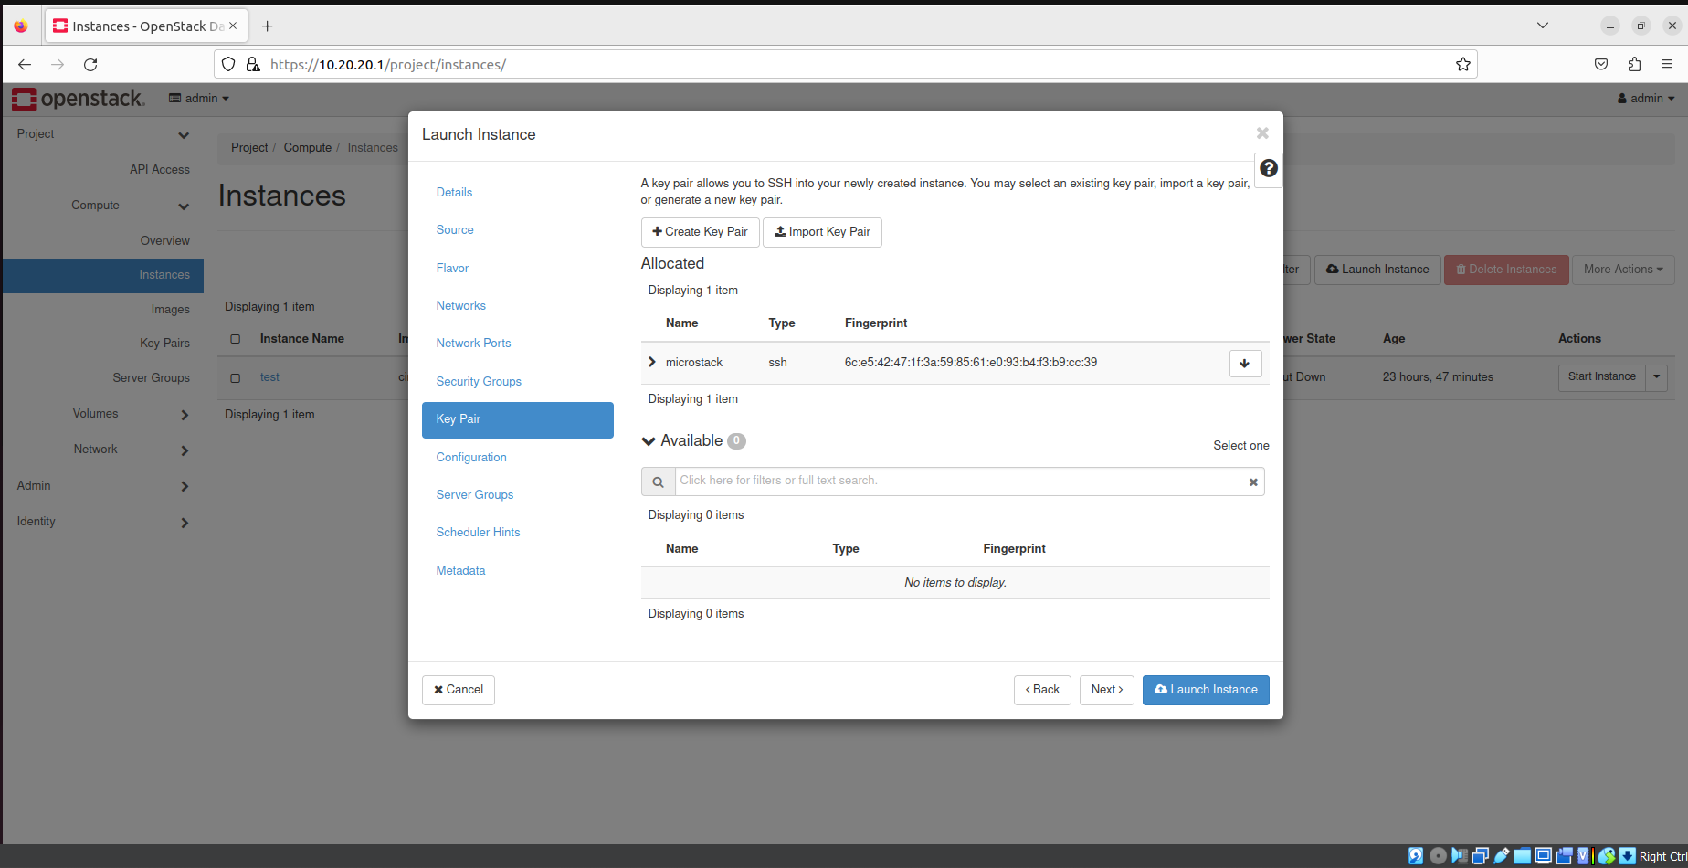

Step 16) Instance is created.

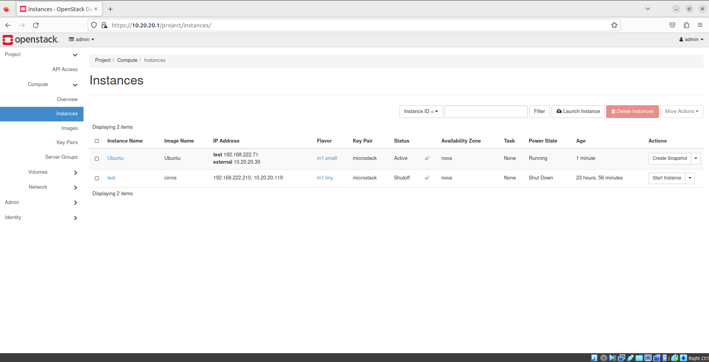

Step 17) Click on the menu in the instance -> associate floating IP.

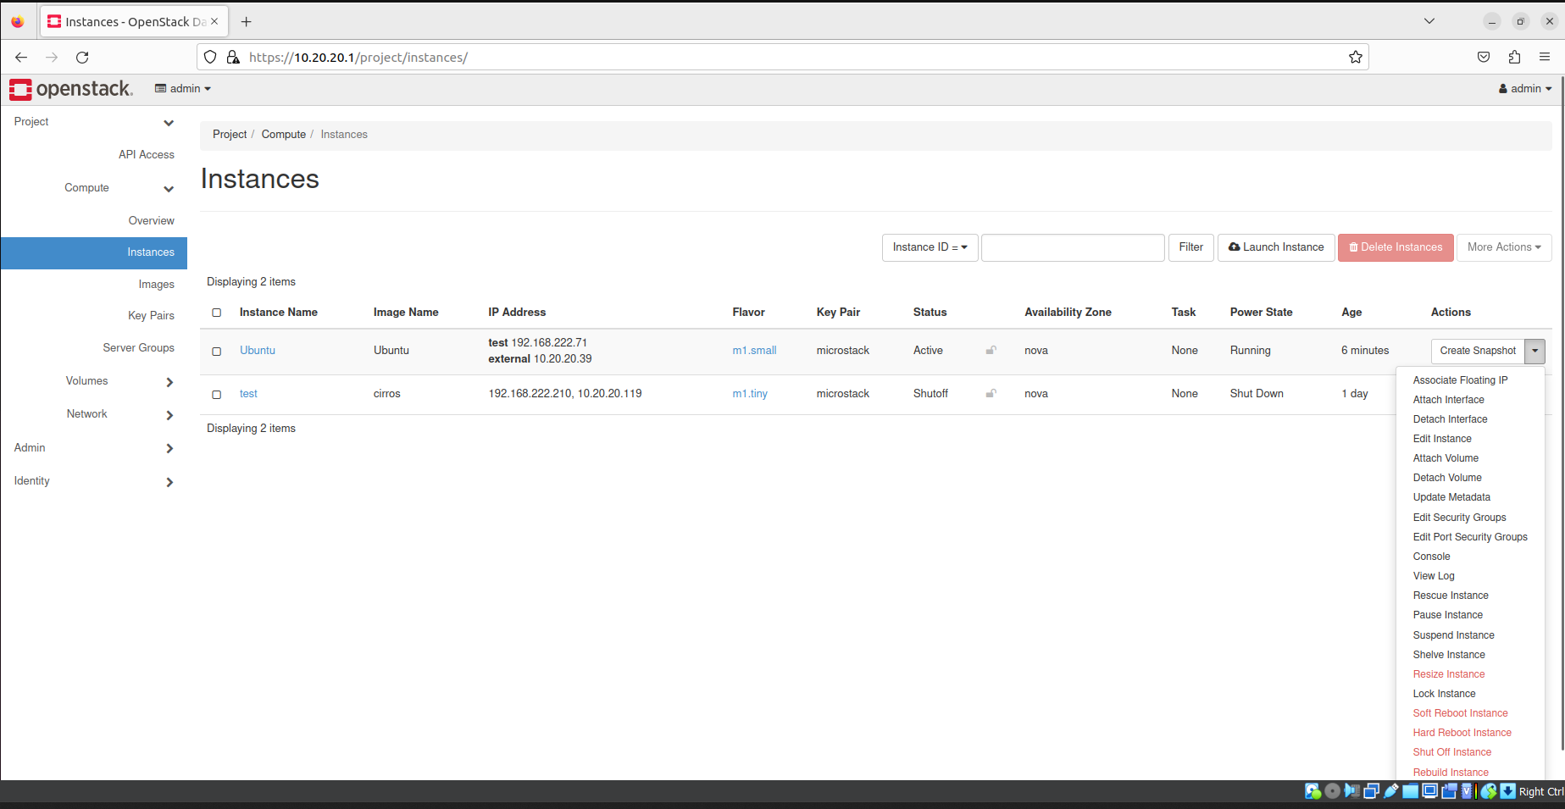

Step 18) Select an Ip from pool.

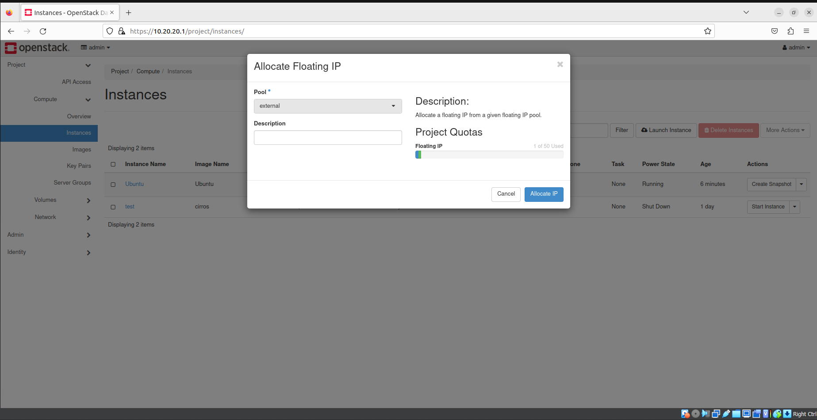

Step 19) IP is selected, and now associate the IP.

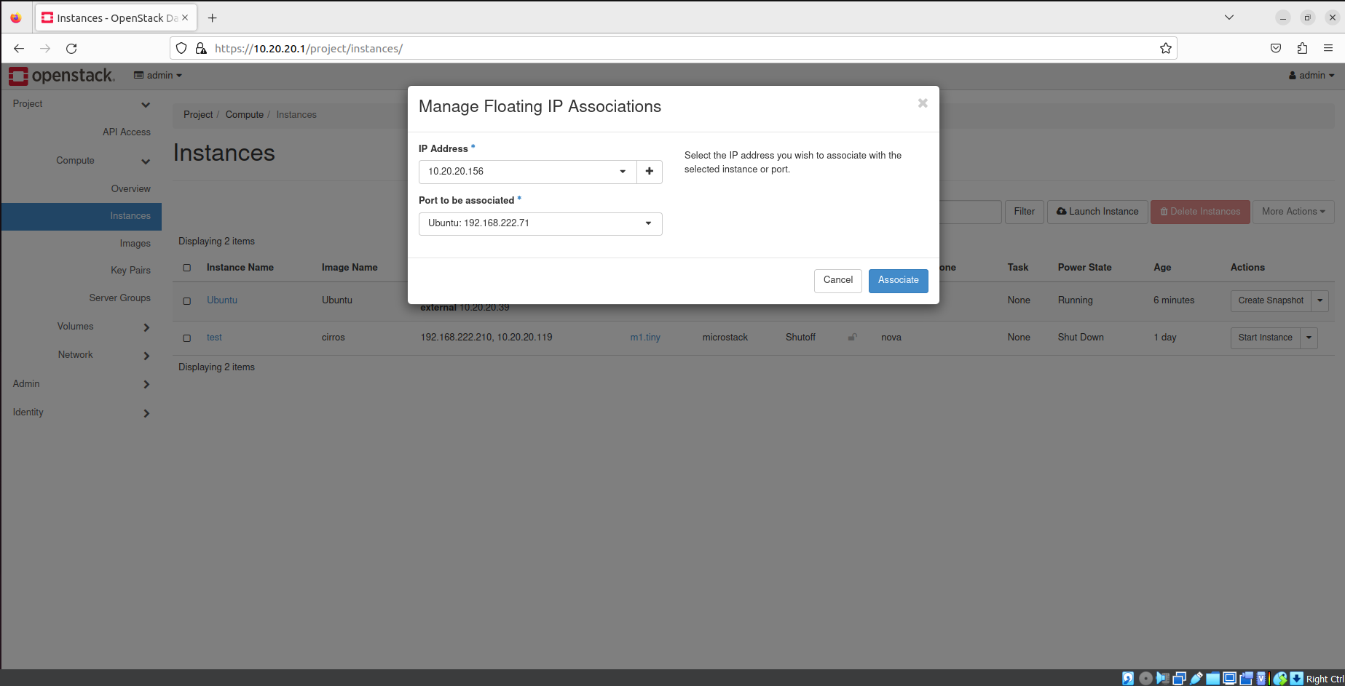

Step 20) Click on the Instance.



Step 21) You can see the overview of the instance.

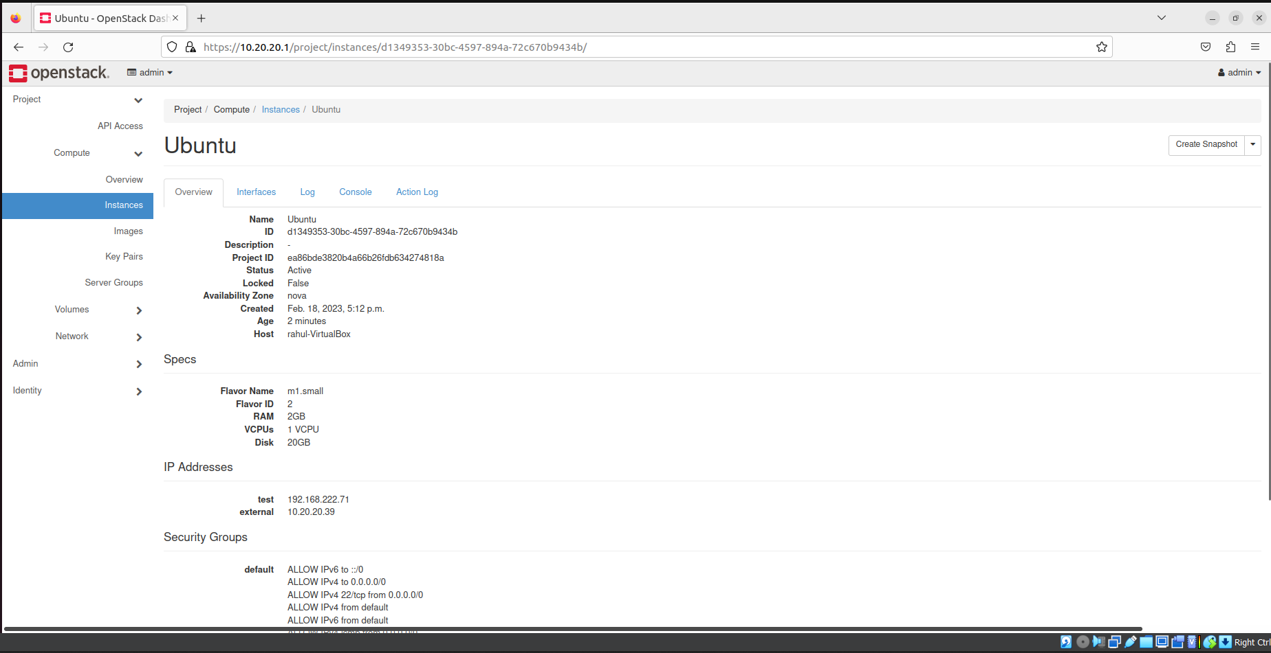

Step 22) Go to console and open it.

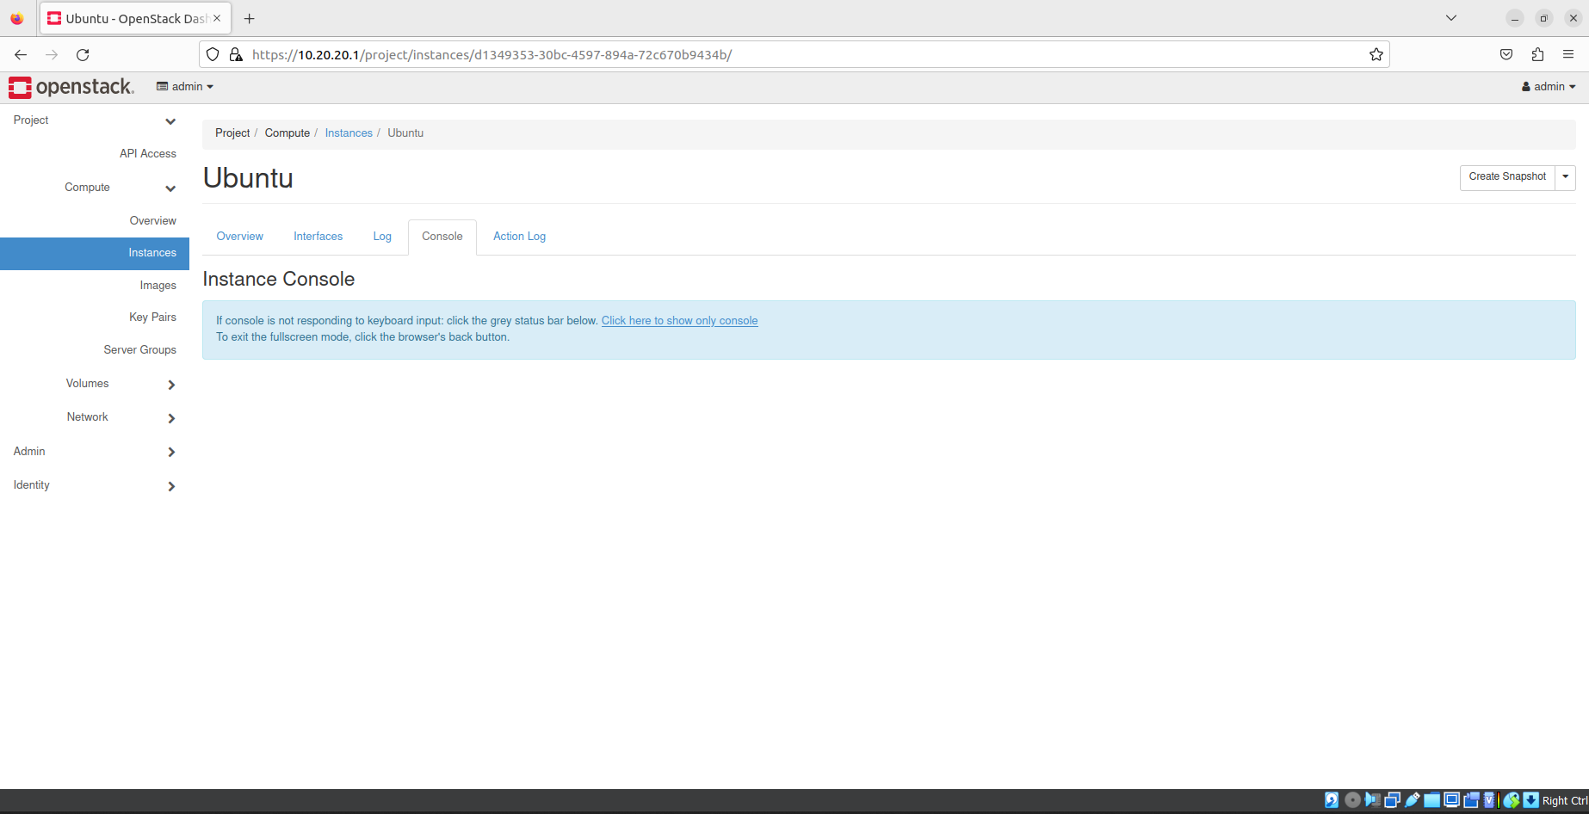 Step 23) Instance Console will open.

